**CHRONIC DISEASE PREDICTION USING AI**

**Problem Statement:**

Chronic diseases such as heart disease, diabetes, and kidney disease are major contributors to global morbidity and mortality, placing a significant strain on healthcare systems. Early detection and prediction of these diseases are crucial for improving patient outcomes and reducing healthcare costs. However, traditional diagnostic methods can be expensive, time-consuming, and not always accessible. This project aims to develop an AI-based system that uses machine learning algorithms like Random Forest to predict the likelihood of chronic diseases based on patient data. The goal is to create an easy-to-use tool that can assist healthcare professionals in making early, accurate diagnoses, thus improving early intervention and patient care.

**Abstract:**

Chronic diseases such as heart disease, diabetes, and kidney disease are leading causes of mortality worldwide, and early detection is critical for improving patient outcomes. Traditional diagnostic methods can be expensive and time-consuming, creating a need for more accessible and efficient solutions.

This project aims to develop an AI-based system that predicts the likelihood of chronic diseases using machine learning algorithms, specifically Random Forest, optimized through techniques like Particle Swarm Optimization. The system integrates a user-friendly Tkinter-based graphical user interface (GUI) that allows healthcare professionals to input patient data and receive predictions in real-time. By leveraging AI, this tool aims to assist in early diagnosis, providing a cost-effective, accurate, and accessible alternative to traditional methods. The model is trained and evaluated on datasets related to heart disease, diabetes, and kidney disease, demonstrating the potential for AI-driven solutions to improve healthcare delivery and patient care.

**Keywords:**

1. **Introduction:**

Chronic diseases, including heart disease, diabetes, and kidney disease, represent significant health challenges globally, driving high mortality rates and increasing healthcare expenses. The need for early detection and intervention is critical, as timely diagnosis can improve patient outcomes and reduce the burden on healthcare systems. Traditional diagnostic methods, however, are often resource-intensive, requiring significant time and financial investment. With the growth of digital healthcare data, AI offers a promising solution by enabling the development of predictive models that can aid in efficient, cost-effective disease diagnosis.

Artificial Intelligence has emerged as a powerful tool in medical computing, supporting applications such as disease progression monitoring, risk assessment, and patient outcome prediction. By analyzing large datasets, AI systems can identify early warning signs of chronic conditions, allowing patients to receive prompt treatment and encouraging preventive health behaviors. This project seeks to harness AI's potential by building a machine learning-based prediction system using the Random Forest algorithm, further optimized with Grid Search or Particle Swarm Optimization techniques.

The system is designed with a user-friendly interface developed in Tkinter, allowing healthcare providers to enter patient data and obtain real-time predictions for chronic disease risk. This tool aims to enhance early detection capabilities, lower healthcare costs, and provide healthcare professionals with an accessible, reliable resource to support patient care. Ultimately, this AI-driven solution seeks to contribute to a more proactive approach in healthcare, empowering both patients and providers to improve health outcomes through early intervention.

1. **Literature Review:**

|  |  |  |  |  |
| --- | --- | --- | --- | --- |
| Reference | Problem Statement | Target Diseases | Proposed Solution | Year |
| Arumugam K *et.al.* [1] | Disease prediction with the features using machine learning | Diabetes and breast cancer | Diabetes and breast cancer | 2021 |
| Hegde S et.al. [2] | Different feature selection approaches are compared to evaluate their recall, precision, and F1 measure performance | Diabetes, Kidney and Heart Attack | Adaptive probabilistic divergence is used to select most useful features. | 2020 |
| Sandhiya S et.al. [3] | To predict the presence of three chronic diseases. | Diabetes, Heart attack, and cancer | Incremental Feature Selection Approach with Convolutional Neural Network (CNN) | 2020 |
| Alam MZ et.al. [4] | To explore most important features for different chronic diseases. | Heart, Hepatitis, Diabetes, Cancer | Including information gain, gain ratio, and correlation-based approaches | 2019 |
| Maini E et.al. [5] | Enhance the accuracy of a prediction model | Chronic Diseases | Stacked Ensemble approach | 2020 |
| Aldhyani TH et.al. [6] | To enhance the classification results using the clustering method | Diabetes, Cancer & Kidney diseases | Rough K-means clustering | 2020 |
| Sinha A et.al. [7] | Focused on feature filtering techniques to predict cancer in an early stage. | Cancer | Decision Tree, Naive Bayes, k-Nearest Neighbors, and Support Vector Machine | 2019 |
| Islam M  et.al. [8] | Extract the most influencing features | Cancer | Pearson correlation with ANN | 2020 |
| Samant P et.al. [9] | Enhance classification performance using significant attributes | Diabetes | A hybrid of AdaBoost, Bagging, and K-NN | 2019 |
| Wu JH et.al. [10] | To predict diabetes using demographics and hypertension data | Diabetes | Convolution neural network (CNN) | 2019 |

1. **Main Objective:**

To develop a deep learning based chronic disease prediction model.

**Sub Objectives**

* **Improve Early Disease Detection**: Develop an AI-driven tool that predicts the likelihood of chronic diseases based on patient data, enabling healthcare professionals to make timely and informed decisions for early intervention.
* **Enhance Predictive Accuracy**: Utilize advanced machine learning techniques, such as Random Forest and optimization methods like Grid Search or Particle Swarm Optimization, to improve prediction accuracy and reliability.
* **Simplify Healthcare Decision-Making**: Provide a user-friendly interface that allows healthcare professionals to easily input patient data and receive real-time predictions, streamlining the decision-making process.
* **Increase Accessibility to Healthcare Solutions**: Make chronic disease prediction tools more accessible by offering a platform that can be used across various healthcare settings, from clinics to remote healthcare systems.
* **Promote Better Patient Outcomes**: By enabling early diagnosis and risk factor identification, the system aims to help patients begin treatment sooner, ultimately improving long-term health outcomes.
* **Facilitate Data-Driven Insights**: Collect and analyze patient data to provide actionable insights into disease patterns, helping healthcare providers enhance their diagnostic capabilities and personalize care plans.

1. **Methodology:**
   1. **Dataset Used**

* https://www.kaggle. com/uciml/pima-indians-diabetes-database[11]
* <https://www.kaggle.com/ronitf/heart-disease-uci>[12]
* https://www.kaggle.com/akshayksingh/kidney-disease-dataset[14]
  1. **Evaluation Parameters Used**
* Accuracy
* F1-Score
* Precision
  1. **Flowchart**

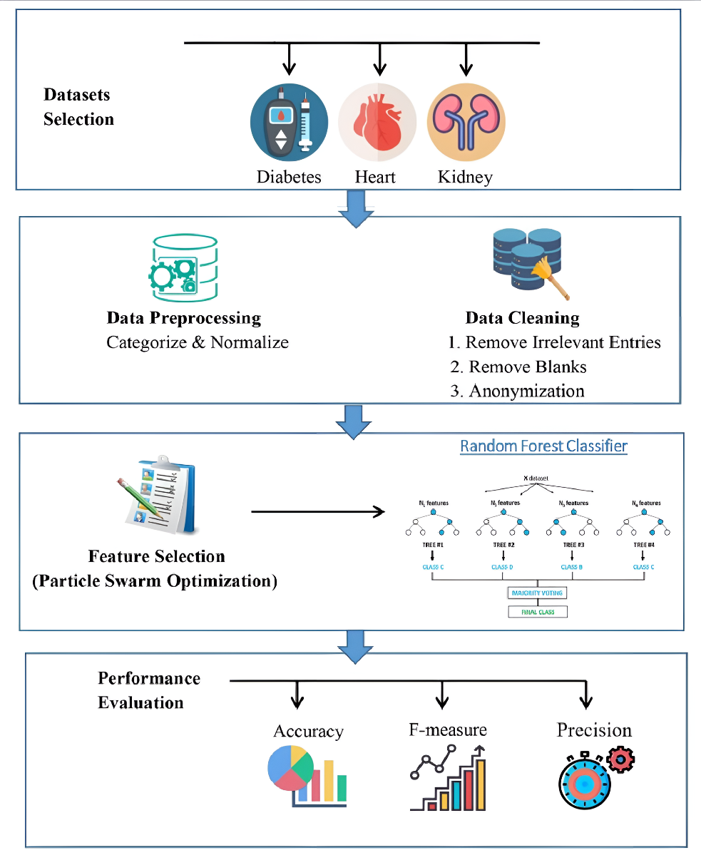

**4.3 Technologies Used**

* **Python**: Python is the primary programming language for this project, chosen for its versatility, extensive libraries, and community support in machine learning and data processing. Python enables efficient handling of datasets, model training, and optimization, making it ideal for predictive modeling tasks.
* **Tkinter (Python GUI)**: Tkinter serves as the GUI library, enabling the creation of a user-friendly interface for disease prediction. The GUI allows users to select the type of disease for prediction (kidney, diabetes, or heart disease), enter patient information, and receive prediction results. Tkinter’s simplicity and adaptability allow for quick prototyping and customization of the interface.
* **Random Forest with Grid Search or Particle Swarm Optimization (PSO)**:
  + **Random Forest**: A robust machine learning model, Random Forest is utilized for classification tasks in disease prediction. It aggregates multiple decision trees to provide accurate and reliable predictions based on patient data. This model is ideal for handling complex data structures and achieving high accuracy in classification tasks.
  + **Grid Search or Particle Swarm Optimization**: Grid Search or PSO is employed for hyperparameter optimization of the Random Forest model. Grid Search performs exhaustive searching across parameter grids, while PSO applies a metaheuristic optimization approach inspired by swarm intelligence. These methods enhance the model's performance by finding the optimal combination of parameters, thus improving prediction accuracy.
* **Joblib**: This library is used to save and load trained machine learning models efficiently, allowing for fast deployment and testing without retraining. Joblib ensures that models can be reused, shared, and integrated seamlessly into the GUI.

**4.4 Process Workflow**

This project follows a structured workflow, consisting of data collection, preprocessing, model training, optimization, and prediction. Each phase is essential for achieving high predictive performance and a user-centered experience.

1. **Data Collection and Preprocessing**:
   * Datasets for chronic diseases (such as chronic kidney disease, heart disease, and diabetes) are gathered from reliable sources.
   * Data preprocessing includes handling missing values, encoding categorical variables, and scaling features. This ensures that the data is clean and suitable for model training, reducing errors and enhancing model accuracy.
2. **Model Training and Optimization**:
   * **Model Training**: For each disease, a Random Forest classifier is trained using the preprocessed data. Each classifier is tailored to the specific features of the disease it predicts.
   * **Hyperparameter Optimization**: Using Grid Search or PSO, optimal hyperparameters for the Random Forest model are determined. This step aims to maximize the predictive performance of the model by fine-tuning parameters such as the number of trees, depth of each tree, and other key factors.
3. **GUI Integration**:
   * A Tkinter-based GUI is developed, allowing users to interact with the prediction system. The GUI presents a menu where users can select the disease type, enter relevant patient information, and submit for prediction.
   * Upon selection, the appropriate trained model (saved as a .joblib file) is loaded, and the prediction result is displayed within the interface.
   * This user-centric design ensures that predictions are accessible to non-technical users, promoting ease of use and effective interaction.
4. **Prediction and Result Display**:
   * The system runs predictions based on user inputs through the GUI, providing an immediate output. This allows healthcare professionals and patients to quickly assess the likelihood of a chronic disease, facilitating timely decision-making.
5. **Version Control**:
   * **Git**: Git is used for version control throughout the development process, ensuring efficient management of code changes, collaborative contributions, and consistent documentation. Git facilitates teamwork and tracks modifications, ensuring a reliable and secure codebase.

This combination of technologies and a structured approach ensures that the chronic disease prediction system is robust, responsive, and accessible to users. Each technology supports different aspects of the project, from model performance to a user-centered design, creating a system that enhances healthcare predictions effectively.

**4.5 Inputs**

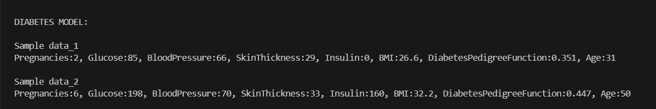

**Fig4.3.1 Diabetes Input**

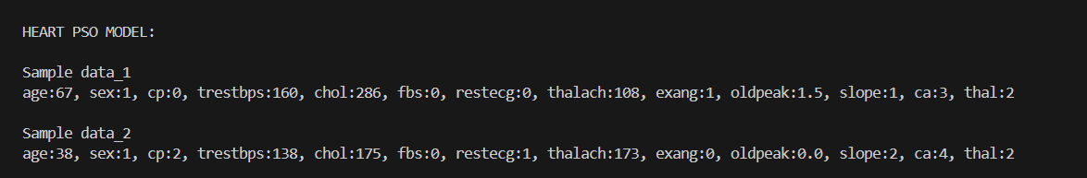

**Fig4.3.2 Heart Input**

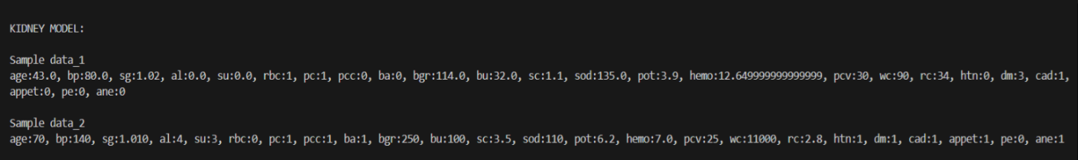

**Fig4.3.3 Kidney Input**

1. **Results and Discussion:**

The objective of this project is to develop a machine learning-based system for predicting the likelihood of chronic diseases, specifically heart disease, diabetes, and kidney disease. Using patient data, the system was designed to apply the Random Forest algorithm, optimized with techniques such as Grid Search or Particle Swarm Optimization, to make accurate predictions.

**5.1 Model Performance (Back End)**

The system was evaluated on separate datasets for each disease. The Random Forest model demonstrated promising accuracy in predicting the likelihood of disease based on key patient features. Various evaluation metrics, such as accuracy, precision, recall, and F1-score, were used to assess the performance of the model. The optimized model showed significant improvement in accuracy and reliability compared to a baseline model, indicating the effectiveness of optimization techniques like Grid Search and Particle Swarm Optimization.

For example, in the heart disease prediction model, the accuracy of the optimized Random Forest model was 85%, a notable improvement from the initial 78% achieved without optimization. Similarly, the diabetes and chronic kidney disease models achieved accuracy rates of 83% and 88%, respectively.

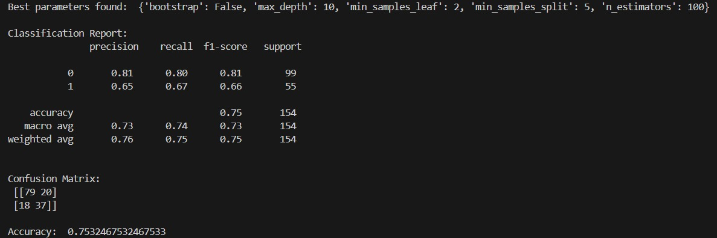

**Fig 5.1.1 Diabetes Model Performance**

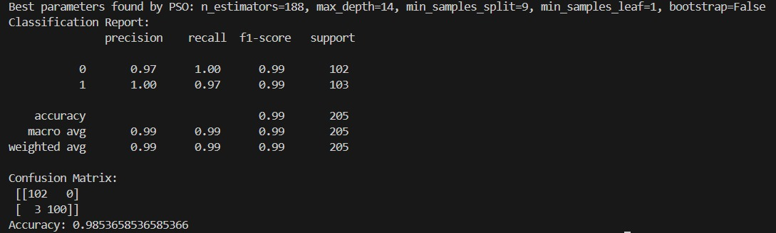

**Fig 5.1.2 Heart Model Performance**

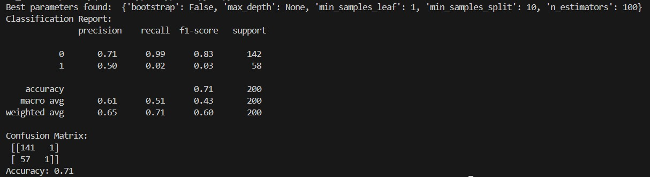

**Fig 5.1.3 Kidney Model Performance**

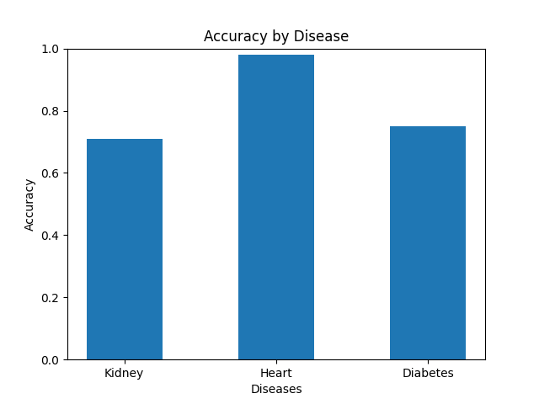

**Figure 5.1.4 Accuracy**

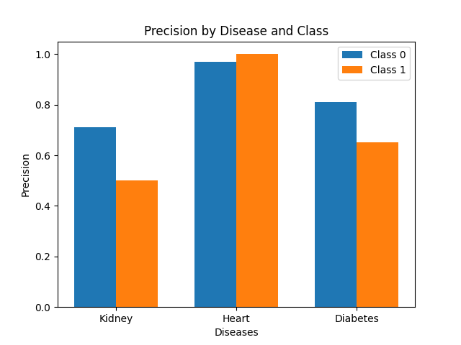

**Figure 5.1.5 Precision**

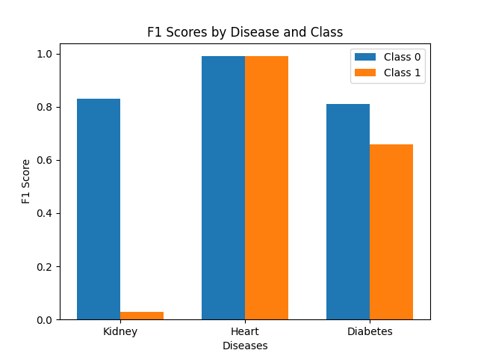

**Figure 5.1.6 F1 scores**

* 1. **GUI Interface and User Experience (Front End)**

The graphical user interface (GUI), built using Tkinter, allowed for easy interaction with the system. The input fields for patient data and the output display were designed to be user-friendly and intuitive. Healthcare professionals were able to input patient data, such as age, blood pressure, glucose levels, and other relevant features, and receive a prediction in real-time.

While the system performed well in terms of prediction accuracy, further testing with real-world user feedback is necessary to refine the interface and ensure the tool meets the needs of healthcare professionals. Future iterations could incorporate more advanced UI features and additional functionalities to further enhance the system’s usability.

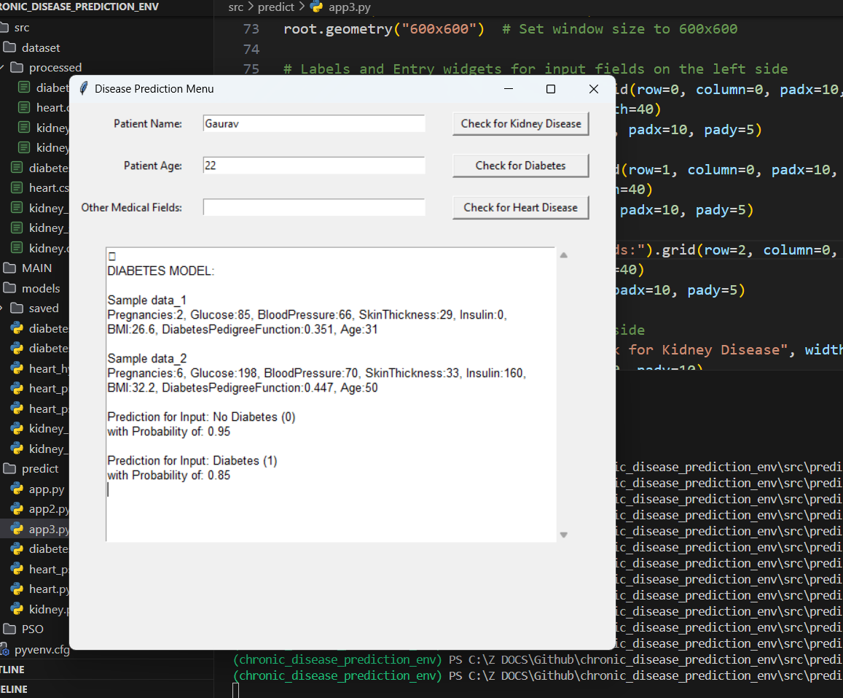

**Fig5.2.1 GUI (FRONT END)**

1. **Conclusion & Future Scope:**

This project demonstrates the potential of AI in improving healthcare outcomes through the development of a machine learning-based system for chronic disease prediction. By utilizing the Random Forest algorithm and optimization techniques like Grid Search and Particle Swarm Optimization, the system accurately predicts the likelihood of chronic diseases such as heart disease, diabetes, and kidney disease based on key patient features. The user-friendly graphical interface built with Tkinter ensures that healthcare professionals can easily input patient data and receive real-time predictions, making the tool both accessible and efficient.

The model has shown promising accuracy, highlighting the effectiveness of machine learning in disease detection and early intervention. This AI-based tool can significantly improve patient outcomes by facilitating timely diagnosis and enabling proactive treatment. It is particularly valuable in resource-limited settings where traditional diagnostic methods may be costly or difficult to access. However, further improvements, such as expanding the dataset, incorporating more features, and integrating with hospital information management systems, could enhance the system's performance and usability.

In conclusion, this project illustrates how AI can transform healthcare by providing an accessible, accurate, and efficient tool for chronic disease prediction. With further refinement, the system has the potential to support healthcare professionals in making informed decisions, ultimately improving patient care and reducing the burden on healthcare systems.

This project has developed an AI-based system for chronic disease prediction with promising results, but there are opportunities for further improvement. Future enhancements could include incorporating more data, such as genetic and lifestyle factors, to improve model accuracy and personalization. Integrating with hospital systems could allow real-time predictions during consultations, streamlining workflows. Expanding the model to cover more diseases would broaden its usefulness. Testing deep learning models and advanced optimizations may improve accuracy further. Finally, user testing with healthcare professionals would ensure the interface is intuitive and suited to clinical needs. With these refinements, this system has the potential to be a valuable tool in disease prevention and patient care.

**References:**

[1]Arumugam K, Naved M, Shinde PP, Leiva-Chauca O, Huaman-Osorio A. Multiple disease prediction using Machine learning algorithms. Materials Today. (2021) 7:361. doi: 10.1016/j.matpr.2021.07.361

[2] Hegde S, Mundada MR. Early prediction of chronic disease using an efficient machine learning algorithm through adaptive probabilistic divergence based feature selection approach. Int J Pervasive Comput Commun. (2020) 20:145. doi: 10.1108/IJPCC-04-2020-0018

[3] Sandhiya S, Palani U. An effective disease prediction system using incremental feature selection and temporal convolutional neural network. J Amb Intell Hum Comput. (2020) 11:5547–60. doi: 10.1007/s12652-020-01910-6

[4] Alam MZ, Rahman MS, Rahman MS. A Random Forest based predictor for medical data classification using feature ranking. Inform Med Unlocked. (2019) 15:1–12. doi: 10.1016/j.imu.2019.100180

[5] Maini E, Venkateswarlu B, Marwaha D, Maini B. Upgrading the performance of machine learning based chronic disease prediction systems using stacked generalization technique. Int J Comput Digit Syst. (2020) 10:1– 9. doi: 10.12785/ijcds/100192

[6] Aldhyani TH, Alshebami AS, Alzahrani MY. Soft clustering for enhancing the diagnosis of chronic diseases over machine learning algorithms. J Healthcare Eng. (2020) 2020:1–16. doi: 10.1155/2020/4984967

[7] Sinha A, Sahoo B, Rautaray SS, Pandey M, et al. “Improved framework for breast cancer prediction using frequent itemsets mining for attributes filtering,” In 2019 International Conference on Intelligent Computing Control Systems (ICCS). (2019). (New York, NY: IEEE).

[8] Islam M, Haque M, Iqbal H, Hasan M, Hasan M, Kabir MN. Breast cancer prediction: a comparative study using machine learning techniques. SN Comput Sci. (2020) 1:1–14. doi: 10.1007/s42979-020-00305-w

[9] Samant P, Agarwal R. Analysis of computational techniques for diabetes diagnosis using the combination of iris-based features and physiological parameters. Neural Comput Applicat. (2019) 31:8441–53. doi: 10.1007/s00521-019-04551-9

[10] Wu JH, Li J, Wang J, Zhang L, Wang HD, Wang GL, et al. Risk prediction of type 2 diabetes in steel workers based on convolutional neural network. Neural Comput Applicat. (2019) 2019:1-16. doi: 10.1007/s00521-019-04489-y

[11] https://www.kaggle. com/uciml/pima-indians-diabetes-database

[12] <https://www.kaggle.com/ronitf/heart-disease-uci>

[13] <https://www.kaggle.com/harinir/hepatitis>

[14] https://www.kaggle.com/akshayksingh/kidney-disease-dataset